Git ASSignment : 1

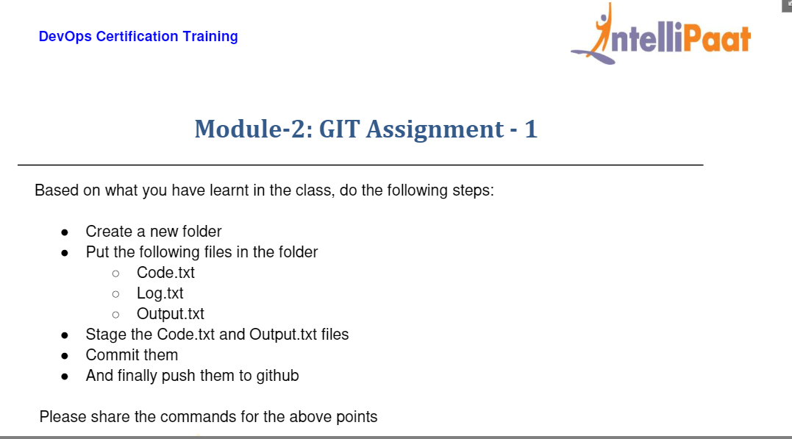

Create ec2 instance and launch it

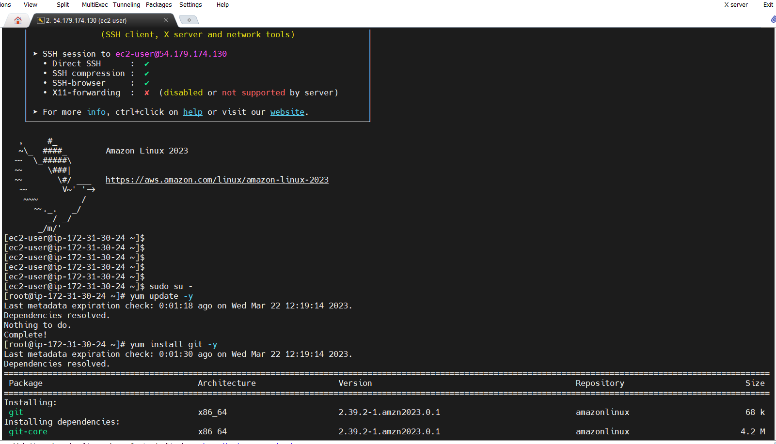

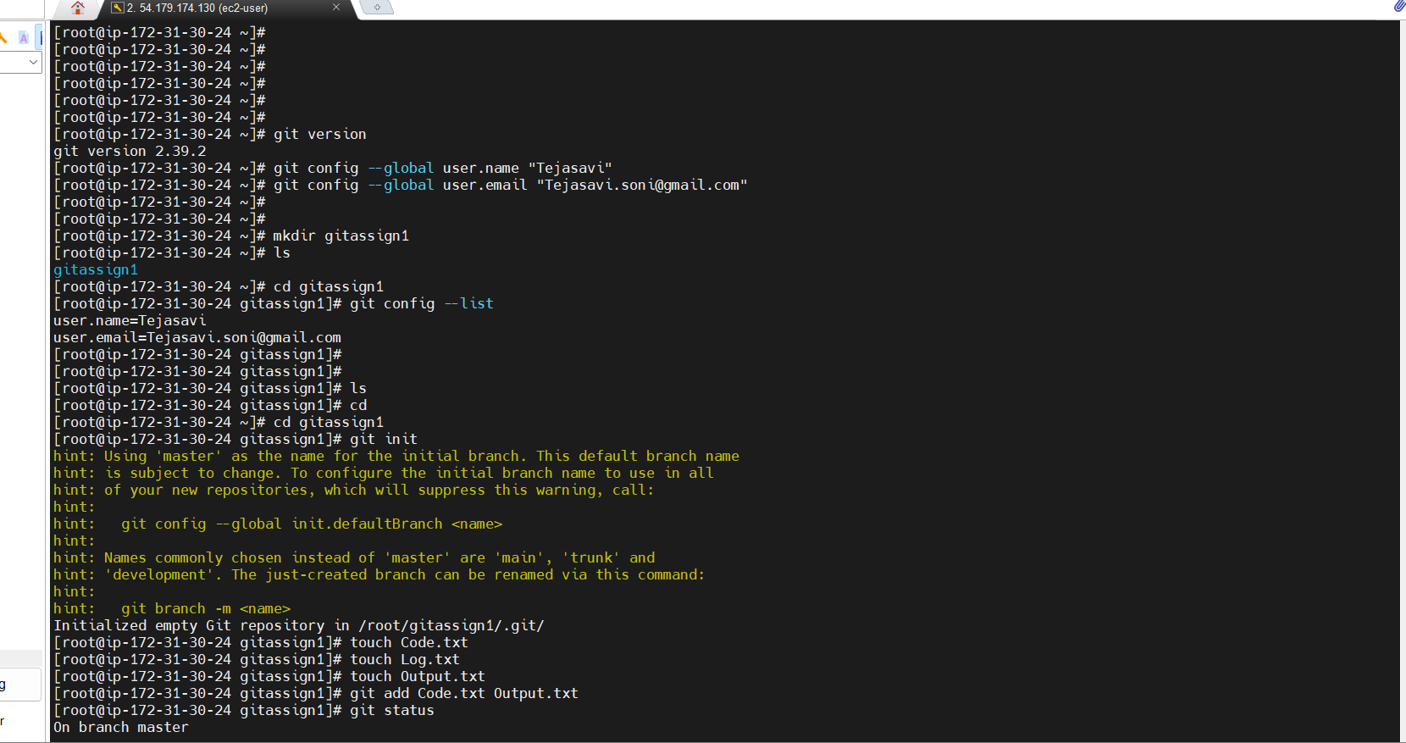

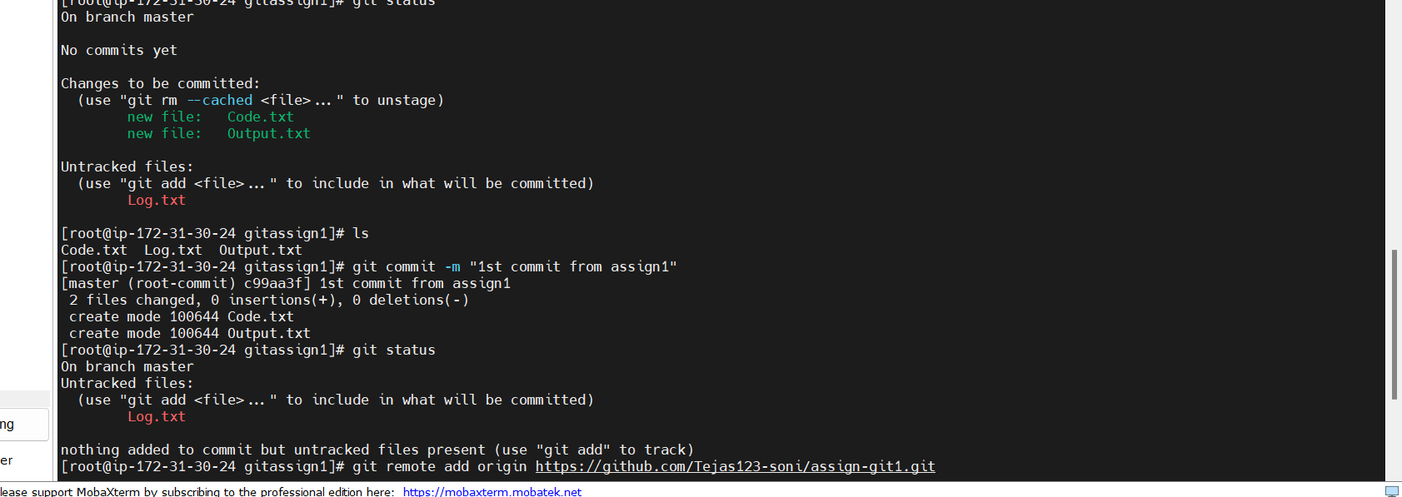

1 yum update -y

2 yum install git -y

3 which git

4 git version

5 git config --global user.name "Tejasavi"

6 git config --global user.email "Tejasavi.soni@gmail.com"

7 mkdir gitassign1

8 ls

9 cd gitassign1

10 git config --list

11 ls

12 cd

13 cd gitassign1

14 git init

15 touch Code.txt

16 touch Log.txt

17 touch Output.txt

18 git add Code.txt Output.txt

19 git status

20 ls

21 git commit -m "1st commit from assign1"

22 git status

23 git remote add origin https://github.com/Tejas123-soni/assign-git1.git

24 git push -u origin main

25 git push -u origin master

26 history

[root@ip-172-31-30-24 gitassign1]#

